SCDC Organizational Profile

PROFILE WITH LEGAL STATUS OF THE NGO:
Sungabha Community Development Center (SCDC) is a non-governmental, non-profit, non-political, and non-religious organization based in Rupandehi District, Nepal. The organization was legally registered with the District Administration Office (DAO), Rupandehi, in 28 September 1997 under the Organization Registration Act and has been affiliated with the Social Welfare Council (SWC), Nepal, since 2007.
SCDC is dedicated to improving the quality of life of marginalized, disadvantaged, and vulnerable communities through inclusive and sustainable development initiatives. The organization works in the areas of education, women's empowerment, disability inclusion, health promotion, livelihood development, and community capacity building.
In collaboration with government agencies, development partners, and national and international organizations, SCDC designs and implements community-based programs that promote social inclusion, economic empowerment, improved access to essential services, and community resilience.
Guided by the principles of transparency, accountability, participation, gender equality, and sustainability, SCDC envisions an inclusive, equitable, and self-reliant society where every individual can live with dignity and realize their full potential.

VISION:
Justice-able and equitable society

MISSION:
To improve the quality of life of marginalized and vulnerable communities through inclusive, sustainable, and community-led development initiatives that promote equity, empowerment, and social justice.

GOAL:
To bring the change in life of targeted groups

OBJECTIVES:
  - Improve the socio-economic conditions of marginalized, disadvantaged, and vulnerable communities through inclusive and sustainable development programs.
  - Promote quality education, health, nutrition, and WASH services to enhance the well-being and quality of life of children, youth, women, and communities.
  - Empower women, youth, and persons with disabilities by promoting leadership, skills development, economic opportunities, and social inclusion.
  - Strengthen sustainable livelihoods through vocational training, entrepreneurship development, agriculture, and income-generating activities.
  - Promote gender equality, human rights, child protection, social inclusion, and good governance in all development initiatives.
  - Enhance community resilience to climate change, disasters, and humanitarian emergencies through disaster risk reduction and environmental conservation.
  - Strengthen the capacity of local governments, community institutions, and civil society organizations for participatory and accountable development.
  - Build partnerships and contribute to the Sustainable Development Goals (SDGs) through innovative, community-driven, and evidence-based development programs.
STRATEGIES FOR PARTNER DEPLOY:
- SCDC has commitments for the community to contribute 10-15 % of resource of community for any development activities
- Community Based Action Committees such as SAMVAD Support Team (SST), VPAC, Village AIDS Coordination Committees, Child Clubs, Women Network for Women and Domestic Violence Control are functioned for their rights and development with regular technical support of SCDC
- SCDC inhibits the “Free Basic Education” by Government of Nepal as Mandatory tool for the accessibility of education for all
- “Adolescent and Youth are the key change agent to transform the society“ is the main resource mobilization tool of SCDC for the social change and development
- Social inclusion and good governance is practiced at all program and personal level
- Use of past experience in the implementation of SAMVAD project
- Human respect and dignity in all level for social justice.

SUMMARY OF PAST PROJECTS AND KEY ACHIEVEMENTS
SCDC over the years has been running different projects and program in collaboration with different organizations in the sector of Community Development, Education, Health, HIV/AIDS, Women Empowerment and Advocacy part to enhance the livelihoods and education status of Women, Children and Adolescents. Key achievements from previous projects were as follows:
S. N | NAME OF PROJECTS | KEY ACHIEVEMENTS
1. | HIV/AIDS Project | - 5 VACC has been formed at local government level and are mobilized for prevention of HIV/AIDS.  - 76 HIV infected people have formed AWAZ Samuha at local level and transmission rate has been reduced by 51%.  - Community people are aware on HIV/AIDS and have reduced the discriminative behavior towards HIV/AIDS infected people.
2. | Anti Human Trafficking | - 396 families Benefitted from the Project implemented by SCDC, United mission to Nepal funded Project from 2017-2021  - 7 Women groups formed and are in mobilization to fight against Human Trafficking & 5 Adolescents groups who have been educating other adolescents to protect themselves from trafficking.
3. | Adolescents Sexual Reproductive Health Project | - 550 families benefitted from the program implemented by SCDC, United Mission to Nepal Funded Project from 2018 to 2020.  - ASRH groups formed and mobilized in 12 School of two working municipals.  - Adolescents’ girls’ friendly school Health Corner supported in 12 Schools.  - Adolescent’s girls friendly Health Service strengthen in working Municipals and working wards.  - Adolescents Peers to peers’ education system has efficient sensitizing on ASRH in schools and in community.
4. | SEEDS/SAMVAD Project | More than 3000 adolescents have improved in life skills and have built confidence to protect themselves  - 397 drop out adolescents are re-enrolled in school;  - 20 child marriage cases stopped by Adolescents & Youth Forums  - 14 Graduate adolescents’ networks have been formed and mobilized for advocacy and campaigning work. Few of its achievement are as follows:  - Under the campaign called “Tole Tole ma wada” (Government services to doorstep) organized by SATHEE network together with local Government, the program was able to provide birth certificates and citizenship recommendation to 68 adolescents. The campaign has been appreciated and it was replicated in other VDC as well.  - The learning of SAMVAD has been appreciated by local government so Kanchan Rural Municipal supported for the operation of 5 school SAMVAD where more than 282 students of class 8, 9 and 10 participate on weekly SAMVAD discussion. The discussion facilitated by the network adolescents and received NRs. 200/class from the school.  - Working Rural Municipal have supported Existing adolescents & Graduate Network forums allocating budgets to implement Network plan mentioned in Palika Red book.
5. | Mental Health Project | - In total 209 mental health affected people are in recovering stage after receiving the treatment;  - Reduced social discriminative behavior towards mental health affected people;  - Co-ordination has been increased with government line agencies;  - Mental health affected people have good access to services provided by government hospital.

EXECUTIVE COMMITTEE/BOARD MEMBERS

SN | Name | Designation | Work Experience) | Tenure
1 | Amrita Thapa | Chairperson | 15 Year | 29-01-2025 to 29-01-2027
2 | Hema Belbase | Vice chair person | 10 years | 29-01-2025 to 29-01-2027
3 | Pushparaj Sapkota | Secretary | 3 Years | 29-01-2025 to 29-01-2027
4 | Khadananda Gyawali | Treasurer | 4 Years | 29-01-2025 to 29-01-2027
5 | Pomnath Gotame | Vice-Secretory | 20 Years | 29-01-2025 to 29-01-2027
6 | Lata Shreeis Magar Kshetri | Member | 2 Years | 29-01-2025 to 29-01-2027
7 | Tilkumari Khatri | Member | 5 years | 29-01-2025 to 29-01-2027
8 | Shobhakhar Acharya | Member | 10 Years | 29-01-2025 to 29-01-2027
9 | Deb Bahadur Phauja | Member | 2 Years | 29-01-2025 to 29-01-2027
10 | Kamala BK | Member | 4 Years | 29-01-2025 to 29-01-2027
11 | Jaykala Gotame | Member | 3 Years | 29-01-2025 to 29-01-2027

ORGANIZATIONAL STRUCTURE

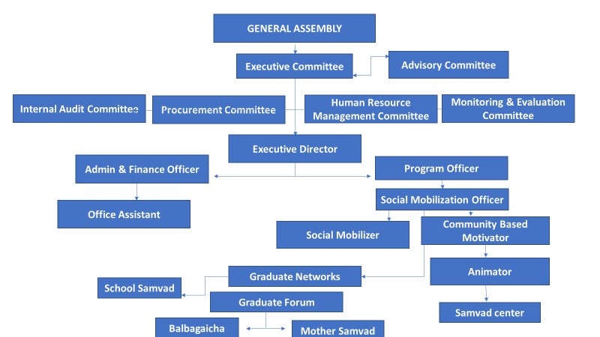

PLAN AND POLICIES
- Strategies and sustainable Development Plan
- Personnel and Administrative Management Policy
- Child Protection Policy
- Local Resource Mobilization Policy Centre plan
- Financial policy (Procurement Policy)
- Revolving fund mobilization policy
- Anti-Corruption & Whistle Blowing Policy
- Scholarship Policy
- Volunteers’ mobilization Polices
- GESI Policy
- Do No Harm Policy
- Environment and Climate Change Policy
- Participatory monitoring and Evaluation Policy

